***A Research Study:***

**E- Business developments and skills requirements in the retail sector.**

**Submitted in fulfilment of the requirements of W&RSETA ILDP accredited by Henley Business School.**

**MEMBERS OF SYNDICATE:**

* **Manthe Shinners**
* **Lynette Surajpal**
* **Ntsiki Kotoi**
* **Rishen Done**
* **Micheal Mojapelo**
* **Zaid Manjra**



# TABLE OF CONTENTS

1. **Executive summary 3**
2. **Problem Statement 4**

**3 Description & background to the opportunity and its importance 4**

**4 Goal Statement 5**

**5 Aim of Research 5**

**6 Rationale 6**

**7 Literature Reviewed 6**

**8 The Scope of our Research 7**

**9 Our research aims to answer the following questions 7**

**10 Out of Scope 7**

**11 Methodology 8**

**12 E-business and its value? 10**

**13 Looking at local and international online retailing 10**

**14 The Rate of Technology Change and its Impact 11**

**15 Changes in Consumer Trends 14**

**16 South African retail and the impacts of e-Business 15**

**17 Benefits of e-business 16**

**18 Recommendations 19**

**19 e Business Case 27**

**20 References 30**

**21 Appendices 31**

1. **Executive Summary**

E-Business is growing at a rate of around 30 percent a year, with the growth showing no signs of slowing down. Indeed, with some major consumer brands and chains not yet having devised comprehensive online retail strategies, the scope for future growth is even greater.

The scope for future skills development in this area will also have a direct impact on the economy of the country across big business and small business alike.

With SMEs accounting for about 7.8-million jobs in South Africa, this means as many as 1.56-million jobs would be in jeopardy were it not for the Internet.

According to a recent World Wide Works study that has revealed that the Internet economy contributes 2 percent to South Africa’s gross domestic product (GDP). Moreover, this contribution is rising by around 0.1 percent a year, meaning it should reach 2.5 percent by 2016.

We have witnessed Government spending on infrastructure increase over the years to better position government and business to leverage new technologies and changes in the internet landscape.

The increase in internet users is largely accredited to the rapid increase in smart phones across the country and in Africa. We are seeing various applications across internet banking, online shopping, access to information and immediate communication.

A massively positive trend also emerges in Africa. If half of all Africans are using phones, it means that the majority of Africans have in their hands a communications device that can be used almost anywhere. It gives access to family, friends and information on an unprecedented scale.

Therefore, the opportunity for retailers in South Africa looking at creative solutions to do business in Africa, may be to consider looking at online business as an immediate solution. The opportunities in e-business span across the organisation ranging from the front end customer interactive side, to the entire supply chain and back end and internal processes that enable the front end to be delivered.

With the rapid growth in e-business developments, the need to acquire the right skills across retailers will be pivotal in which retailers gain a competitive advantage in this area.

The skills that are necessary to make retailers competitive are a combination of deep technical skills, astute commercial acumen and strong leadership and change management skills. The changes would need to be leader led and driven with focus and determination throughout the organisation.

Some retailers are clearly leading the way while others are late adopters. One thing is very clear; to remain relevant, retailers would need to know their online audience and the ever growing internet population. Retailers need to think differently regarding sustainable e-business strategy that is focused on consumer trends. Acquire the appropriate skills to stay ahead in a dynamic environment where technology is changing in a nano second.

1. **Problem Statement**

**Consumers are increasingly using the latest technologies in their everyday lives and unless retailers embrace these technologies and develop the skills to implement them, retailers would become irrelevant and cease to exist in the immediate future**

1. **Description & background to the opportunity and its importance**

This report defines e-business importance, e-business adoption and its impact focusing on the major activities that consumers and businesses can now perform, describes the types of customers who are more likely to participate in e-business, and it also outlines the prediction of e-business future success.

There are tremendous changes taking place in the world of technology, some incremental, and some game changing. The pace of change and regularity of it is mind blowing. Many of these technological advances could have application in retail environments, but to adapt and adopt these developments requires a new way of thinking and doing things, most of which have not been done before.

An extreme example of adapt and adopt of technology developments, is the development of drone technology for military purposes, that Amazon are looking at to make deliveries to customers.

Another example is screening technology to profile customers. Once again this had initial application in the security industry to alert and detect behaviour and profiles that has subsequently been used to profile customers and predict shopping behaviours. It also seems like an app can be developed for virtually any need for smart mobile devices. However, in order to leverage these developments in commerce, new skills would have to be learnt and capacity developed to adapt the technology, implement and maintain it and ensure that it is used effectively. Having the technology is one thing, but using it effectively to maximise its value to an organisation is an altogether different proposition. A number of publications have illustrated this point with regards to big data. Many organisations have access to massive amounts of data, but the value of it depends of how analyses the data to it useful information that can be used for effective decision making.

The thinking is moving so quickly that before one can adopt any of these changes the game rules change. First mover advantage gives one competitive advantage not only to stay get ahead of the game, but requires constant change to stay there.

E-business has changed the way companies do business; it offers buyer and sellers a new form of communication and provides opportunities to create a new marketplace. This electronic business has a major impact on the retail industry in a variety of ways. Retailers have had to adapt to new technological demands from users to allow them to participate in the e-business world. e- Business has created new activities and features in which consumers and businesses can participate.

1. **Goal Statement**

**Our goal is to implement key technologies that will give us competitive advantages into the future. We will do this by developing skills to enable us to effectively implement these technologies and to sustain this progress by developing capacity.**

**The technology is viewed as an enabler to deliver on the business strategy and the only way to ensure that the technology is leveraged to maximize its potential is to build the skills to maintain and enhance it, as well as to ensure its future applicability. Building organizational capacity therefore ensures the sustainability of the advantage that allows the business to be successful in the longer term. Key to this capacity is the investment in people. This advantage is not easily purchased or replicated. This was a theme that was repeated with many of the businesses that were visited in the international immersion.**

1. **Aims of our Research**

* To look at current e-business developments in retail.
* Rate of change of technology and its Impact
* Looking at local and international online retailing
* South African Retail and the impact on e-business
* Outline the benefits and Value of e-business in retail
* Skills requirements for a sustainable e-business future

1. **Rationale**

* To acknowledge the value of e-business in the South African retail sector.
* Leveraging of available technology to enhance the customer experience.
* To investigate current trends and technological advancement and usage.
* Growth in Online Sales and what percentage influences profitability and economic growth.
* Growth in Mobile Commerce and what does that mean for the consumer and the retailer.
* Growth in Grocery and Apparel retail online
* Social Media as a new platform for Commerce
* To explore a possible strategy and approach to online retailing.
* Develop a Multi Channel Strategy
* Develop a Digital Strategy
* Develop a Flexible Fulfillment Strategy
* Develop an E-Commerce Core Competence
* To determine and clearly articulate the disadvantages of not having an online shopping channel.
* E-commerce is borderless, it is scalable.
* Business will not be able to account for loss sales if they choose to not go online.
* Increasingly South Africans are online: do we capitalise on this channel to do business.
* Determine the skills required across the business.

1. **Literature Review**

The technology trends identified in Accenture’s 2014 Digital Consumer Technology Survey show that consumers continue to explore many different device types, formats and combinations. Consumers are not limiting themselves to a few multifunction devices, but instead have increased the number of digital devices. Wearable technology, digital trust and increased usage of apps are all trends that bear watching.

The digital experience engaging the connected customer.

Consumers increasingly seek new, immersive digital experiences in which they control the action, from any device in any location. To achieve high performance while engaging the connected consumer, broadcasting companies must provide innovative, end-to-end multi-screen video services while reducing time to market and operational costs. Thriving in this environment means finding new ways to engage audiences, monetize those engagements, and better manage the user experience and content workflow.

This demands new business and operating models that break from the past. It calls for new ways to integrate and harness broadcasting innovation to drive value in a fast-changing digital landscape. It demands technology mastery and business insight to drive out the value now presenting itself to businesses in every aspect of the industry.

1. **The Scope of our Research**

The primary objective of this research initiative is to identify the skills that are required to support retail.

In addressing the primary objective the team will seek to understand the e-business developments and the necessary skills required to for a sustainable e-business retail model.

Understand the benefits of e-business and skills to support e-business

Investigate and identify areas within the wholesale and retail sector where there is a lack of skills.

Leverage international practices and lessons learnt with reference to the development of retail skills, by reviewing and evaluating them, to understand if they can be adapted, adopted and implemented within the SA context.

1. **Our research aims to answer the following questions**

* What are the technological developments that’s driving change
* How can these be applied in Retail
* What are the global and international trends leading the way
* Can these be applied in the African context
* What can Africa be the leaders in
* What are the skills that are required to develop the competencies that would make these developments successful in retail
* How does one develop these skills
* What are the advantages and benefits of developing the technologies and skills
* How do we make these skills sustainable and a competitive advantage

1. **Out of Scope**

We have also included as an appendix further research on the following areas that will continue to Impact e-business.

* E – Government – *Appendix B*
* E- Marketing – *Appendix C*

1. **Methodology**

* **Research Methods**
* Observation and experience
  + - This research method is done by watching the process as it happens.
    - Local and international retail store experiences.
    - We examine the online methods, surveys coming at the best in terms of benefits.
* Broad based online research on e- business/ e-commerce/Omni channel/ mobile and African Markets.
* Focus Group
  + - Same as the interview but covers wider number than one on one interview.
    - Focus group – discussion with various departments at TFG/ Marketing/planning / buying departments.
* Discussions - One on One discussion with various stakeholders
* Interviews (structured and unstructured)

|  |  |  |  |  |  |  |
| --- | --- | --- | --- | --- | --- | --- |
| Type | Source | Where | How | Target | Who | When |
| Desktop Research | SETA data base. Internet Research. World Wide Works. Harvard Business Reviews | Online Sources. Group work | Online | Numerous | Zaid Lynette Manthe  Micheal  Ntsiki  Rishen | July 14  Augt 14  Sept 14  Oct 14 |
| Interviews | Foschini Group e-commerce department.  Woolworths  Pick n pay  International  Brands.  Nike  Shop Beam | Cape Town  Durban  JHB  Canada  New York  Washington | Via Skype  One on One interviews  Questionnaires  Retail  Safari’s in  USA.  e-mail | 10 | Lynette  Rishen  ALL | Aug 14  July/Aug  Sept 14 |
| Questionnaires | Foschini  Woolworths  Pick n Pay  Markham  American  Swiss  @Home | Cape Town  Durban  JHB | e-mail | 50 | Rishen  Manthe  Lynn  Micheal  Ntsiki  Zaid | July/Aug |
| Various Industry papers | Harvard Business Review  World Wide Works  Effective  Measures  E-commerce Report. | Online  Sources  e-books | Group conference calls monthly.  e-mails | 30 | ALL | June 14  July 14  August 14    Oct 14 |

1. **What is E-Business and its value?**

E-business (electronic business) is the conducting of business on the Internet, not only buying and selling but also servicing customers and collaborating with business partners.

The processes and tools that allow an organization to use Internet-based technologies and infrastructure, both internally and externally, to conduct day to day business process operations. E-Business stands for electronic business and refers to any kind of sales, services, purchasing or commerce on the Internet. It is a new-tech jargon word used more for marketing than for technical description. Most commonly it broadly refers to conducting business over the Internet (email and web) by communicating and perhaps transacting (buying and selling) with customers, suppliers, and business partners.

We believe that e-business is an all encompassing term that includes all forms of electronic or digital application in business, whereas Omni-channel (popularised more recently) relates channels of trade between retailers and consumers, therefore being more specific and with a narrower reference. We, therefore, regard Omni-channel as a subset of e-business.

1. **Looking at local and international online retailing including the developing world.**

E-Business is expanding faster in the developing world, driven by the rapid penetration of smart phones. Coupled with Africa's above-average economic growth, this presents unprecedented retail opportunities and is on time, given that it is probably not a good time to invest in building new shopping malls across Africa.

The concept is taking off faster in developing countries than in the developed world. In Brazil, e-business is growing at a rate of 84% per year and it is already a $500-million per year market.   
  
Brazilians shop online for fashion, health products and electronics, which illustrates why the growth of e-business is so exponential in the developing world, shopping online allows consumers access to globally recognized brands that may not have a retail footprint in their area, or even in their country.   
  
By expanding and prioritizing their online shopping portals and partnering with the right express courier, retailers are no longer bound by their country's borders anymore; they can sell to anyone, anywhere.

**Taking a closer look at the US markets we see the rapid growth projected for online business.**

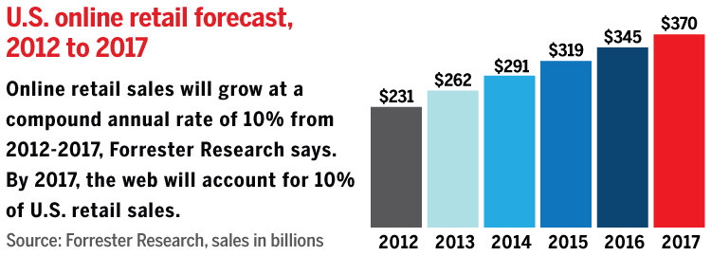

1. **The Rate of Technology Change and its Impact**

Today’s customers expect to be able to connect with the retailer digitally – because they live digitally connected. Global Internet usage will more than double by 2015, and most of these users will be mobile.

Every retailer must therefore be a digital retailer. The pace of technology is accelerating, and the barrier to entry is lowering. It’s no longer enough to be friendly with customers, have good industry connections or rely on a brick and mortar store on the high street.

Smart phones has revolutionized our world and according to a recent survey done by Effective Measures in 2013 we find that many South African internet users use their smart phones to access the internet whilst others use traditional methods of access.

The smart phones revolution and advances in future technology will continue to change the face of retail.

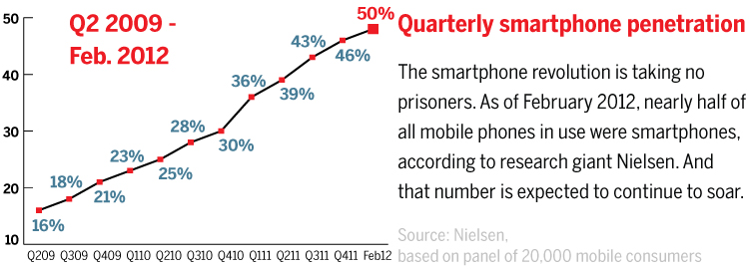

Mobile Commerce: The reason consumers buy ComScore finds 63% of Smartphone owners buys via m-commerce for the on the go convenience. 41% buy because they are in the store and the store is out of stock.

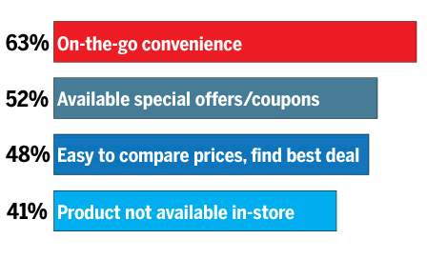

Source: ComScore

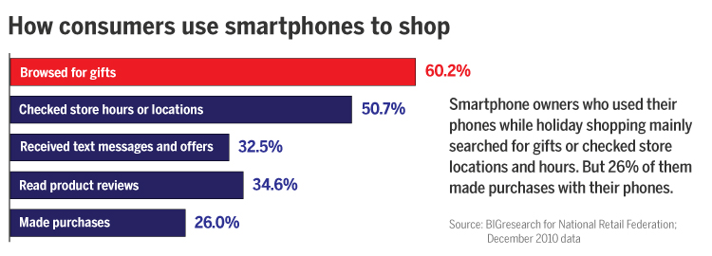

Here is an assessment of specific technologies that are available on the market today.

There are some questions related to how business would leverage of these technologies to focus providing a seamless experience for the customer as well as develop the skills to manage systems integration, analyse data, and improve customer service.

* Wearable Computing

What are the wearable technologies in the market today - Google Glass, Recon Jet, Fit bit, Pebble Smart watch, Apple I Watch.

How can they be used to improve employee efficiency, customer service, store experience?

What new services can they enable?

* Digital Payments

Mobile Wallets, M-Pesa.

What is being deployed in retail today?

How can we use digital payments to increase loyalty and differentiate the shopping experience?

* Location-based Services

What are the options to track customers?

Mobile phone tracking,

What are the technology/cost tradeoffs for different technologies?

* Crowd Sourcing

What are the available platforms to harness the power of the crowds?

How can a retailer enhance their business processes via crowd participation in areas like merchandising, home delivery and private shopper, store analytics, plan-o-gram compliance?

* Drones

Amazon has announced their intent to deliver up to 86% of their product categories via drones in fewer than 30 minutes in select markets. Can it be done?  What are the current capabilities of drones?  What are the regulatory, safety, and business considerations?

What are the associated risks with the use of Drone Technology?

* 3D Printing

With 3D Systems – What are the strengths and limitations of current printing technologies and materials?  Is there a risk factor to consider?

* Cyber security

In an increasingly digital world, what are the technologies and methods a retailer can focus on in areas of Threat Intelligence?

* “Big Data” Platforms

Everyone is talking about “Big Data” but the reality is that there have been a significant number of new technologies that have emerged that provide businesses with the architecture / capacity to ingest, store, process, and act upon the flood of structured and unstructured data available to a retailer. Businesses need a straightforward framework to put the myriad of technologies in context and to map data use cases to technology investments.

* Data Visualization

The next generations of business intelligence tools are emerging to enable the business analyst, store manager to see the patterns emerging in large, complex data.

* Virtual / Augmented Reality

State of the art in 3D modeling, immersive digital environments, visual field overlays that can be used to redefine store planning, in-store shopping experiences, online / in-home digital shopping.

* Digital Technologies in Emerging Economies

A look at specific use case where very low cost Android mobile devices to help people in rural environments to sustainably improve e.g. crop yields 20 – 30%

1. **Changes in Consumer Trends**

Key Findings- Effective Measure Surveyed over 10 000 internet users in South Africa on their online shopping habits and uncovered the following key insights.

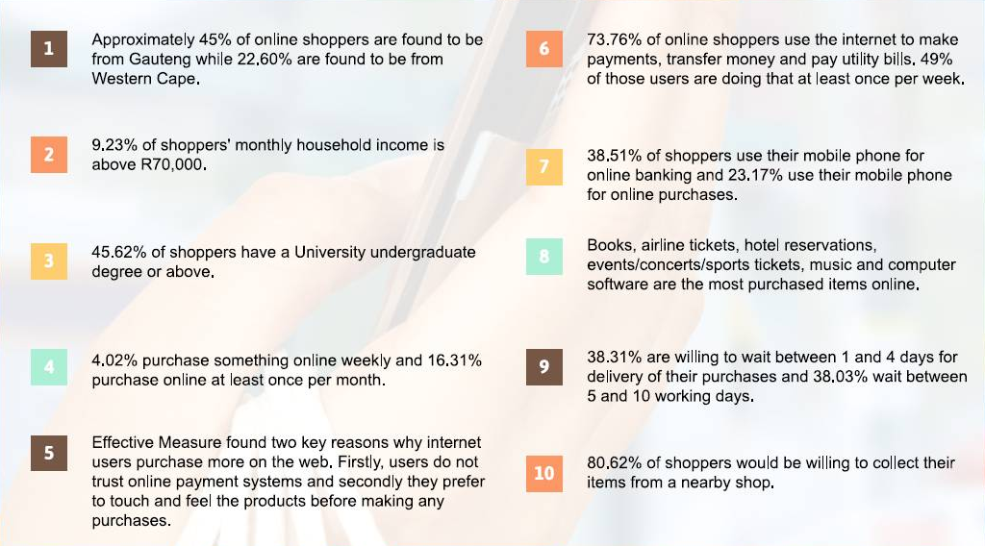

Source: Effective measures survey 2013

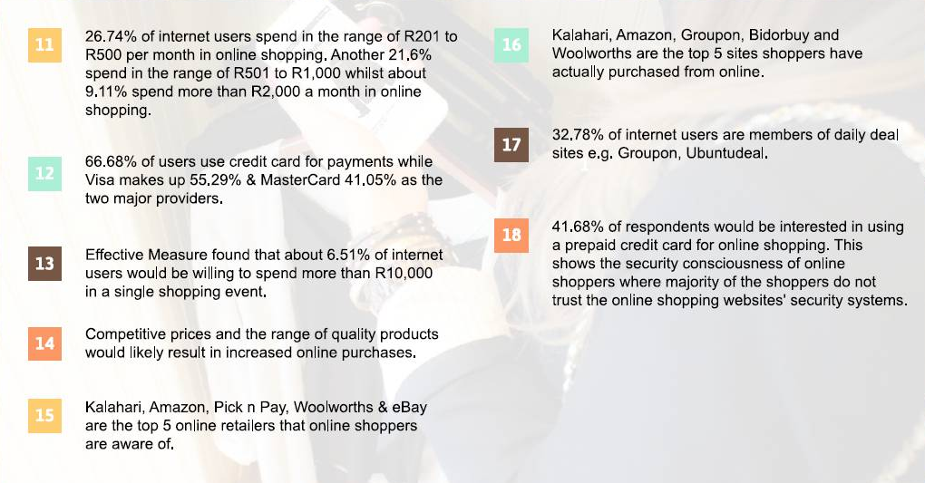

Source: Effective measures survey 2013

1. **South African retail and the impacts of e-business**

**The South African retail landscape has changed with the impact of globalization and international retailers seeing South Africa as a gateway into the rest of Africa. The Market is currently flooded with international brands the likes of Zara, cotton on, Forever 21, Top Shop to name a few. International retailers have sophisticated online supply chains that give then a competitive edge and use technology to talk to the consumer. There it is necessary that retailers in South Africa adapt to stay ahead.**

South African online shopping over Christmas 2013

A recent research study conducted by effective measure in South Africa found that as visits to South African retail websites increase during December 2013, mobile traffic increased to 47%. The increase in mobile activity is indicative if users accessing the internet over Christmas and New Year while away from work.

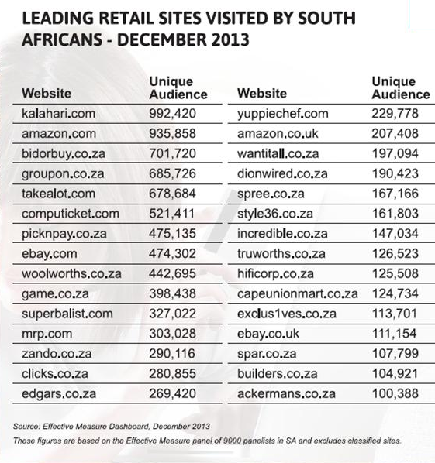

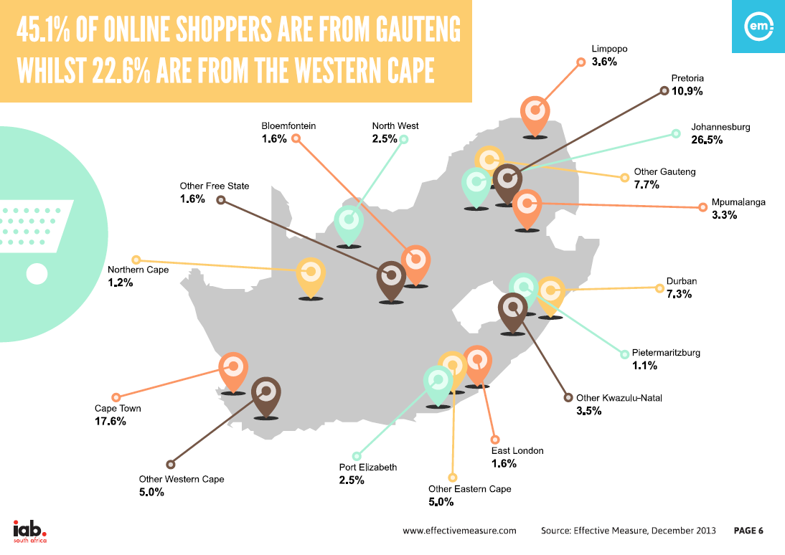

1. **The Benefits of e – business**

* **ORGANISATIONAL BENEFITS**
* Effective business intelligence and information management
* Flexible infrastructure
* Reduction of red tape and administration
* Efficiency in logistics and operations
* Improvement of Brand image
* Effective business intelligence and information management
* Business intelligence should be a priority for the organizations; it starts from top management down to lower management. It is considered that the (BI) can have a direct impact on business performance which will results in improving the ability to realize and accomplish the plans by making smarter decisions at every level from executive to operational. In order to achieve the BI the organization should build the effective strategy which is driven by e- Business objectives; the objective should ensure customer satisfaction and investment capabilities.
* The management of information should be visible throughout the organization and the universe; this will give confidence to consumers that the information is accurate and reliable.
* Management of e-Business data will provide the organization with consistency, information privacy, reliability of security, and will increase the information usability and efficiency.
* Flexible Infrastructure
* Organizations should ensure reliable and flexible architecture use of hardware, software, information data and content that will deliver service to customers, employees and all other stakeholders. Delivering flexible infrastructure will ensure the quality of service by users of the system in terms of speed and responsiveness. Organizations should ensure that all role players including those managing data on their behalf are flexible enough to consider new technologies in order to support the changes required by the business to run effectively.
* Infrastructure should be aligned to all processes of doing business, Business to Business, Business to Customer, Customer to Customer, the system should be fast on communication, is able to process orders fast, to protect customer privacy and trust, and address security concerns.
* Reduction of red tape and administration.
* The benefit will be the reduction of the handling of too much cash within the organizations especially with big retailers as customers will use different electronic payment methods. The errors can be managed though the system as oppose to manual entries which results in the savings of paperwork.
* Efficiencies in logistics and operations.
* The benefits of e-Business logistics improves the competitiveness and the profitability, it provides logistical service solutions required for business networks which will comply with the need of the future customer needs.
* It provides the development of transparency in supply chain resulting in effective and increasing rapid deliveries and optimization of inventories.
* It helps in reducing the work load and helps with management of material flow.
* Improves communication between the operations and administration department.
* Improvement in brand Image
* E-Loyalty is the result of customers trusting the brand based on the delivery promises the organization extends to its customers. The brand will be trusted if is effective on quality security, product offering, on time delivery, innovation, up to date software systems with speed.
* Customer Benefit’s
* Effective and efficient marketing programs
* Streamlined fulfillment of orders
* Improve customer service
* Help customers compare prices for better and cheaper options
* Customers can log in anytime, browse, review, comment and purchase products or service.
* Discounts on products and service.
* Effective and efficient marketing programs.
* The organizations internet pages must be easily accessible, reliable and fast to browse, this will in understanding the customers response so that you can play the next marketing move. Customers must be able to customize their template, upload from anywhere, and be able to send and share and be able to track information.
* The online information must be interesting and relevant to the reader, the web page must be able to stand out and capture the customer’s attention.
* Streamlined fulfillment of orders.
* The best way of managing the fulfillment of orders is go through outsourcing the fulfillment of orders, the key benefits allows organizations to expand their business without growing the size of the operations.
* It is important to choose the partner carefully; the decision should be focus on smooth ordering, transmission and feedback in order to satisfy customers.
* Once all the terms and conditions of the contract are agreed on, the fulfillment company will receive the orders, hold stock, handles and process the orders for dispatch.
* Improved customer service.
* The organization must always keep in touch with their customers; send weekly and monthly email with links back to the website. Inform customers of new products in stock, sale items, special offers, coupons.
* The organizations can further send customers birthday wishes, thank you notes, and ask for any suggestions in order to improve the business. Always keep the website up to date with all the information loaded in the website, e.g. returns policy, shipping information, product description and images, up to date prices.
* Society benefits
* No need to travel to shop a product or service
* Helps governments to deliver service to businesses, society.
* No need to travel to shop a product or service
* The benefits to society should be such that the customers can order products or service and be delivered at their doorsteps in real time, irrespective of where the customers lives, the organizations should plan the business in such a way that the cover all consumers, in Urban, Rural and in any part of the world.
* E business enables people in rural areas to shop and enjoy the products and service that are not available to them.
* Helps government to deliver service to businesses and society.
* E business helps governments deliver public services such as health care, education, social services, and helps reduce the cost of doing business. The government can be able to procure goods and service and reduce costs.
* The other benefit is that government can also act as providers of IT service, ICT, applications and e Business models.
* PRODUCTION
* Higher efficiency
* Learner value chain
* Higher employee engagement
* Manageable reduction of costs
* Higher efficiency
* Learner value chain
* Higher employee engagement
* Manageable reduction of costs

1. **Recommendations**
2. **Total commitment**

It’s up to the chief transformation officer to ensure that your com­pany is the one that not only survives the inevitable transforma­tion, but also thrives after it. Only then can you experience trans­formation not as disruption but as ongoing opportunity that leads to lasting success.

**FEATURED COMMENT FROM HBR.ORG**

Roles of CIOs and CTOs MUST change so that they can be effective business partners with business leader­ship, and so that they can effectively serve and enable their colleagues by systematically implementing new technologies in the company to enable capabilities that executives AND implementers alike.

*Reference Harvard Business Review*

*The above statement drives a key observation that was a common thread throughout our research.*

*Organisations where e-business is a Board objective are organisations that are leading the way with leveraging technologies to improve business processes to meet customer demands.*

*Together a focus on alignment in Marketing initiatives and customer connected data drives real return on investments.*

*Major investment needs to be made in infrastructure and skills to future fit business.*

**2. Looking at skills required**

With major new developments—cloud computing, big data/analytics, mobile technology, increasingly complex supply chains, a globally distributed workforce, etc.—mean that CIOs and their staffs are being asked to support businesses in very different ways.

In a Harvard Business Review on the New CTO, Chief transformational officer. Daniel Burros writes: “In a recent article, I suggested that the role of the CIO needs to shift from chief information officer to chief innovation officer, due to the massive, rapid, multiple technology-driven transformations that are occurring today. And just as the CIO’s role needs to change, so too does the CTO’s—from chief technology officer to chief transfor­mation officer. This fundamental shift is necessary to elevate the position’s contribution and relevance. “

Some of the key Skills required sustaining a successful e-business platform:

* People
* creativity,
* customer centricity,
* technologically savvy,
* business skills
* Technical
* data mining
* web fundamentals
* information systems, computing
* Integration
* multi media and design
* Business
* Ability to simplify.
* Project management
* Ability to co-operate and integrate
* Organizational
* architecture
* agile, nimble and adaptable

**3. Employing and retain staff with the right skills**

According to TWDI 2013 Best practices report on managing Big Data, the following outlines some of the challenges faced with retaining and developing skills.

Being new to big data and its management is the biggest challenge user’s face. When an organization is new to big data, it typically has (relative to managing big data) inadequate staffing or skills (40%), inadequate data management infrastructure (23%), and immaturity with new data types and sources (22%). The cure is to dive in with training and new hires (or consultants, more likely), then work through the learning curve, as with any new project type.

Serious BDM efforts are unlikely without proper business support. It’s difficult for any new project type to get off the ground when it lacks governance or stewardship (33%), business sponsorship (33%), or a compelling business case (27%).Solution design and architecture can be challenging, but not a showstopper. It takes time and angst to work through data integration complexity (30%) and the architecture of a big data management system (25%), but it’s doable for teams with solid data management experience. In a related issue, it’s difficult to determine big data’s role in enterprise data architecture if you don’t have one (25%). This is one reason why many BDM solutions are silos.

Some problems aren’t much of a problem at all. A few issues ranked so low in the survey that we

Should consider them non-issues, namely loading large data sets (13%), fast processing of queries

(9%), scalability with big data (7%), and network bandwidth (4%).

What problems hinder the successful management of big data in your organization?

Inadequate staffing or skills 40%

Lack of governance or stewardship 33%

Lack of business sponsorship 33%

Data integration complexity 30%

Data ownership and other politics 30%

Lack of compelling business case 27%

Cost, overall 26%

Lack of enterprise data architecture 25%

Architecting big data management system 25%

Poor quality of data 24%

Getting started with the right project 23%

Inadequate data management infrastructure 23%

Immaturity with new data types and sources 22%

Lack of metadata and schema in some big data 19%

Handling data in real time 18%

Poor integration among data management tools 18%

Existing data warehouse architecture 17%

Data security, privacy, and governance issues 16%

Cannot make big data usable for end users 13%

Loading large data sets quickly and frequently 13%

Processing queries fast enough 9%

Scalability problems with big data 7%

Inadequate network bandwidth 4%

Other 2%

***Reference TWDI best practices report 2013.***

Job Titles and Team Structures for Big Data Management

The types of people who manage and use big data in their work are surprisingly diverse.

Data architects. Architects of various types are prominent in big data management, especially those

Focused on data, as seen in the job titles data architect (16%)

Managers and directors. Data management requires IT management.

Technical administrators. Managing big data requires administration and systems analyst.

Applications specialists. When an application generates or handles big data, application specialists

Must manage big data. In other words, big data management is not just for data specialists. In fact,

There’s already a tradition of Web application teams managing big data, and that’s exactly where

Hadoop and other technologies and practices for big data came from.

Domain experts. Many end users (who are business people or other non-IT personnel) need to

Manage big data because it’s integral to their work. For example, as with any data, marketers manage big data in support of customer analytics, customer segmentation, profitability analytics, customer profiling, and so on.

***Reference TWDI best practices report 2013***

**4. Collaborate with SMEs**

**Supporting SMMEs:** E-Business has the potential to facilitate growth of small, medium and micro enterprises.   According to reports, in the US, one out of three jobs are created by SMMEs.  It is therefore evident that a faster adoption of e-Business by SMMEs can potentially create some employment in South Africa.  A recent study conducted by BMI-Tech Knowledge group states that of the 600 000 registered SMMEs in South Africa, only 16% of them are conducting e- business. What is even sadder to notice is that 31% of these SMMEs believe they will never use the Internet for business.  The challenge therefore is to empower the SMME sector to take advantages of e-commerce and increase their capacity to participate in the e-driven trading environment.

UNCTAD has cited the necessary conditions that need to be met for SMMEs to realise the potential of e-commerce:

* Access to reliable cost effective telecommunications infrastructure and Internet connectivity.
* Skills and Human Resources (vigorously introduce e-literacy).
* Content - the ability of SMMEs to produce content on the web that will be a key ingredient for broader success
* Trust in the electronic environment.

5. Inclusivity - all driven by e-business

The implementation of end to end processes that integrates supply chain efficiencies and store efficiencies using the latest technology. Including a customer centric approach at every touch point. This process must be beneficial to the supply as well, cut cost and increase ROI. The development of systems and skills must become a business objective at a high level.

**6. Risk – on Line Security**

* **Risk – online security**

The top 8 security threats of 2013

In a year full of them, experts share what they believed to be the biggest securitythreats of this past year

**1) More Sophisticated DDoS**

Attacks continue to become more sophisticated, and that includes advancements in increasing the bandwidth of distributed denial-of-service (DDoS) attacks. The trend has accelerated in recent months, says John South, CSO at Heartland Payment Systems, a large payments processor.

This year saw the continued rise of DoS as a cyber weapon, says Mark Lobel, principal in PricewaterhouseCoopers' advisory practice focusing on security. "The bad actors don't necessarily have to steal your product or service," Lobel says. "They just have to make sure you can't deliver that product or service to your customers, which is a much lower bar than getting in, finding the data and getting away cleanly."

* + 1. **Attack of the Botnets**

Associated with DDoS attacks is the "lethality" of the botnets that have been spreading through systems, South says.

"Using phishing techniques that have gained a much higher level of sophistication, they have been able to drop malware onto large numbers of personal and server-class equipment," South says.

* + 1. **Ignored Insider Threats**

Attacks from within organizations are nothing new. But the number of threats from these seemingly trusted parties is on the rise, says Michael Cox, president of SoCal Privacy Consultants.

“Since these trusted parties have the greatest access to sensitive information, the average cost of breaches caused by trusted parties is greater than those caused by external threats, Cox says.”The false sense of security organizations has with trusted parties have allowed breaches by these actors to grow more rapidly than those by external threats."

For employees, the primary causes of breaches are inadequate awareness and training programs, roles-based access controls and activity monitoring, Cox says. For third-party service providers, inadequate due diligence and monitoring programs are the primary causes.

* + 1. **Insecure Applications**

Another threat that was prevalent in 2013 and will be in 2014 is the production and distribution of insecure applications.

"The proliferation of e-commerce and mobile applications has enabled many companies to have greater connectivity with their clients," South says. But we have yet to solve the resulting problems that have been present for well over the past 10 years: injection and cross-site scripting threats."

* + 1. **Data Supply Chain Threats**

Data supply chain breaches are an emerging threat, says Timothy Ryan, managing director of Kroll Advisory Solutions' Cyber Investigations practice and former supervisory special agent with the Federal Bureau of Investigation.

* + 1. **Unauthorized Access by Former Employees**

Unauthorized network access, especially by former employees, continues to be a security issue for many companies, Ryan says.

"What we're finding is that some companies do not fully sever all the access that former employees were provided," Ryan says. His firm is often called in prior to the termination of an employee to make sure the company effectively terminates access for that individual.

"There have also been incidents where we are called in to investigate an employee whose access was not terminated properly and help assess what has been stolen and how to remediate the issue," Ryan says.

* + 1. **Embedded Systems Vulnerabilities**

Many non-traditional devices are increasingly on networks these days, Taule says, including Internet-enabled cameras, digital video recorders, badge readers and other non-PC devices with an IP address.

"And for those of you who think the Internet of Things–or 'Internet of Vulnerabilities' as I recently heard a colleague quip–is still years off, just ask a peer who works in a hospital and has to deal with untold numbers of network enabled/connected medical devices," Taule says.

"We are fooling ourselves if we think we have our risk exposure well in hand simply by managing the threats to traditional network devices," Taule says. "We must expand our situation awareness capabilities to provide full coverage for everything connected to the network."

* + 1. **The Growth of Bitcoin**

Bitcoin, the open source electronic money and payment network that uses cryptography to secure transactions, comes with its own set of security risks, says Ariel Silverstone, an independent consulting CISO.

Bitcoin is the harbinger of a more digital economy, Silverstone says, but it's vulnerabilities–from the hacking of hosting sites to pure crypto attacks–are just being discovered.

"The fact that multiple attacks on Bitcoin have been so successful, I suspect will lead to renewed attempts at attacking money- and transaction- transferring mechanisms," Silverstone says. "These, such as PayPal, Swift, and also business and bank-initiated environments, transfer trillions of dollars per day. Many of them rely on little security [and are] susceptible to attacks.

* **Customer Focus**

Building user-centered business and experience design practices in the unpredictable world of digital business requires diplomacy, flexibility and, above all, creativity.

In the wild world of digital business, collaboration with peers and clients has been critical to business success. Unlike some who have argued to the contrary, attending to user needs and desires must be the responsibility of all team members, not just a subset.

Ownership of all components of the process should not be equally shared, since not all share the necessary expertise. But all need to play roles in user research, participate in the analysis and experience modelling activities, and apply what is learned to the businesses and business offerings we design. Approaches that prevent collaboration and require handoffs of findings between disciplines or combining independently generated deliverables at the end do not work well.

**WAYS TO IMPROVE CUSTOMER FOCUS**

**1) Go beyond old-style purist approaches to attending to usability**

Standard recipes of attending to "usability" will often be inadequate to specific

Organisations, projects and contexts. Plus, some of our most valuable work extends beyond usability - including using customer-centred activities early so that we contribute to business strategy and plans, and extending concept and design research to attend to brand experience and self-directed exploration.

**2) Respect and value the perspectives of your colleagues and clients**

The multidisciplinary nature of large scale web development highlights the need for usercentered design activities to be carried out with the active participation of the whole team, including visual designers, information architects, business strategists, product managers, marketers, engineers and executive leadership.

**3) Be willing to be creative**

Specific organisations, changing market conditions, and limited resources suggest that there will always be a gap between ideal practice and possible practice. A cookie cutter approach ignores specific challenges and opportunities unique to all of our situations. In addition to what you bring to your organisations, solicit ideas from others in your company and create an environment that fosters idea generation. Be willing to experiment.

**4) Make attention to user experience a key part of your organisations brand**

It is easy to spend all of your time working at the team level, educating, training and creating success stories. You also need to convince your organisation s leadership that customer experience is an essential brand attributes. Such corporate branding will smooth your path, both in working internally and in selling your company’s offerings.

**5) Develop an understanding of the culture of your own organisation**

To really know how to handle its political issues, you must understand what drives your organisation, its values and goals [4]. Just as important as gathering a full understanding of customers for new e-businesses experience design and business strategy, you need to conduct research in your own organisation and understand how your work can contribute to its business objectives. As Rohn argues, you must practice user-centered design on your own organisation [1]. Fortunately, the techniques we use to understand

Customers can also help us understand our organisations.

**6) Develop an understanding of yourself and your own biases**

Your success or lack thereof will emerge from the interaction of your background, expertise and limitations with those of your organisation. Don’t exclude yourself from the process of understanding your organisation. Depending on your situation, you may find that in addition to usability know-how, you all also need to learn more about information visualization, or merchandizing, venture capital funding, field research methods, and the

Path to profitability. And learn how to invite productive collaboration that maximizes the potential of experience strategy experts and non-experts who bring complimentary skills and know-how

**References**

1. Anderson, R. (interviewer and editor). Organisational limits to HCI: A conversation with Don Norman and Janice Rohn. *Interactions*, 7, 3 (May-June 2000), pp. 36-60.

2. Anderson, R. I. Making an e-business conceptualization and design process more users -centered. *Interactions*, 7, 4 (July-August 2000), pp. 27-30.

7. Focus on Simplifying the Customer Experience.

**Customers are demanding it**: They are better connected than ever before and increasingly willing to shop online. This trend is particularly noticeable in the millennial market, our future customer base. These customers prefer to shop when and where it suits them.

**All Retailers** are making investments in this regard: Most major South African clothing retailers and almost all our international peers have already gone online or are about to do so.

The following illustrates 6 key customer touch points that are essential to the retailers’ journey in creating a seamless experience and meeting the consumer demands.

**Front end**

**Integration layer**

**Reporting and analytics**

**Cust mgmt**

**Product mgmt**

**Stock mgmt**

**Stock mgmt**

**Cust mgmt**

*Reference: TFG online strategy*

**19 e-business developments and skill requirements - Business case**

In the development of the business case for e-business, the following should be taken into cognisance:

* It be recognized that the investment is substantial, with returns due over a longer period of time. We have taken a 6 year view to 2020 in making an assessment of returns.
* Our work has emphasized that the breadth of e-business goes beyond the customer facing online business model and includes the digitization of interactions with suppliers and service providers, and the automation and digitization of internal processes
* We have also indicated in our narrative that the new thinking is one of Total Economic Value. This concept advocates that the returns from an online presence cannot be measured based solely on online sales, but a more comprehensive value added to the entire business in whatever form that takes.
* This concept also ties in with the development of thinking from Omni-channel to Total Retail. Total Retail goes beyond channel to the total retail experience.
* The concept of Total Economic Value makes the investment into digital business a much more compelling case

Financial modelling

* The question of how much investment is required to invest in e-commerce can be answered in a typical manner done by economists – it depends!
* It is also critical to understand that the investment required is not just in the technology, which is a large investment, but also in the implementation and sustainability of the solution. This therefore should include the investment in skills and competencies that support the technology investment. While this is often overlooked, it is just as critical an investment for successful execution.
* While there are many permutations and options on how one invests, in what, and how much will it cost, there are 2 fundamental strategic questions that need to be answered. The first relates to the speed and pace of investment, while the second relates to the platform that one uses.
  + Regarding the pace, the options are either a big bang approach that invests in a total solution from day 1, or a gradual investment that is phased over a number of years and which improves over time as and when the scale is developed
  + Regarding the platform, the range of choice depends on how it interfaces with the customer, the range of functionality and flexibility of the system, etc. The range can best be categorized as a gold, silver, bronze choice, with the gold, of course being the more capital intensive.
* The skills required to develop, implement, maintain and operate these systems can also differ vastly, depending on the options chosen, the demand and supply and scarcity of the skills at the time.
* Considerations to be taken into account that would influence the decisions mentioned above include the following:
  + The customer profile and therefore demand for the technology. Even though the proliferation of ownership of mobile phones is high amongst the general population, the behavior and use of such phones in the shopping decision may differ based on shopping habits and preferences.
  + For a customer that is high LSM, very up to date with technology, high expectations of enabled technology and a fully integrated shopping experience, we would recommend a solution that is as close to the fully developed solution as possible. However, for a retailer that is at the other end of the market, we would recommend a more gradual approach to the implementation, to match the customer behavior and expectation.
  + The decision regarding the technology platform should also be informed by the complexity of the business, the functionality required, the existing systems that would need to be integrated, and the skill required to manage and affordability.

Assumptions and financial investment

* An investment

|  |  |  |  |  |  |  |
| --- | --- | --- | --- | --- | --- | --- |
| **Investment in online capability** |  |  |  |  |  |  |
|  |  |  |  |  |  |  |
| **Establishing an online presence** | **TOTAL** | **Yr1** | **Yr2** | **Yr3** | **Yr4** | **Yr5** |
|  | Rm |  |  |  |  |  |
| Capital investment | 60 | 35 | 15 | 10 | 0 | 0 |
| Development Exp | 5 | 4 | 1 |  |  |  |
| Operating Exp | 98 | 6 |  | 25 | 32 | 35 |
| TOTAL | **163** | **45** | **16** | **35** | **32** | **35** |
|  |  |  |  |  |  |  |
| **Ensuring a fulfilment solution** | **TOTAL** | **Yr1** | **Yr2** | **Yr3** | **Yr4** | **Yr5** |
|  | Rm |  |  |  |  |  |
| Capital investment | 25 | 15 | 10 | 0 | 0 | 0 |
| Development Exp | 2 | 1 | 1 | 0 | 0 | 0 |
| Operating Exp | 51 | 7 | 8 | 10 | 12 | 14 |
| TOTAL | **78** | **23** | **19** | **10** | **12** | **14** |
|  |  |  |  |  |  |  |
| **TOTAL SOLUTION** | **TOTAL** | **Yr1** | **Yr2** | **Yr3** | **Yr4** | **Yr5** |
|  | Rm |  |  |  |  |  |
| Capital investment | 85 | 50 | 25 | 10 | 0 | 0 |
| Development Exp | 7 | 5 | 2 | 0 | 0 | 0 |
| Operating Exp | 149 | 13 | 8 | 35 | 44 | 49 |
| TOTAL | **241** | **68** | **35** | **45** | **44** | **49** |

The table above represents the investment over the a 5 year period and has been drawn from data from an existing retailer. However, in the SA environment, we consider this to be the upper end of the range of investment, with the lower end representing about half this spend.

Sales performance

|  |  |  |  |  |  |  |
| --- | --- | --- | --- | --- | --- | --- |
| **Online Sales drivers** |  |  |  |  |  |  |
|  |  |  |  |  |  |  |
| Unique visitors |  |  |  |  |  |  |
| visits per visitor |  |  |  |  |  |  |
| conversion rate |  |  |  |  |  |  |
| Fulfilment rate |  |  |  |  |  |  |
| average basket size |  |  |  |  |  |  |
|  |  | **Yr1** | **Yr2** | **Yr3** | **Yr4** | **Yr5** |
| Sales growth |  | 14% | 10% | 10% | 10% | 10% |
| Online sales as % of total |  | 0.50% | 0.64% | 0.93% | 1.51% | 2.75% |
| Online sales growth |  | 45% | 60% | 80% | 100% | 80% |

South African retailers currently have online sales representing 0.5% of sales. Even with a healthy growth rate ranging from 60% to 100% over the next 5 years, online will still represent sales of less than 3%. Even extrapolating this for another year, increases this to 4.5%.

**Conclusion**

* **South African retailers still have some way to go to reach critical mass in the online contribution to total sales. The factors that inhibit the adoption of online would have to be addressed.**
* **In the short-term, very few e-commerce business or online entity within a business turns a profit. This has been very evident more so in a business of smaller scale, without the benefit of substantial volume.**
* **The recent surprise merger between Kalahari.com and Takealot.com is a case in point, in which once arch rivals, decide to merge to create an entity with scale and reach, in order to make it profitable. It is predicted that there would be other such consolidations taking place in the market place.**
* **In the evaluation of the investment, using Net Present Value (NPV) and the Internal Rate of Return (IRR), taking into account only online sales for a 5 year period, the outcome is a negative one, in a time horizon of 5 years.**
* **However, taking into account Total Economic Value, both the NPV and IRR would represent positive values, in a shorter period of time.**

1. ***Referencing***

* Achieving Total Retail - Consumer expectations driving the next retail business model - PwC
* Accenture: Retail Technology Vision 2014
* Internet Retailer, Amazon sales top $61 billion in 2012 January 29, 2013
* Gartner; Forecast: Devices by Operating System and User Type, Worldwide, 2010-2017, 1Q13 Update March 28, 2013
* Direct Marketing News; Infographic: The Rising King of Social Sales; RetrievedApril 2013 online at http://www.dmnews.com/infographic-the-rising-king-ofsocial-
  + sales/article/290699/
* Accenture; A New Era for Retail: Cloud Computing Changes the Game; Retrieved May 2013 online at http://www.accenture.com/us-en/Pages/insight-retailcloud-computing.aspx
* Bloget, Henry; The Business Insider, The Future of Mobile; Retrieved March 2012 online at http://www.businessinsider.com/the-future-of-mobiledeck-2012-3#-11
* IDC report, Always Connected: How Smartphone’s and Social Keep us Engaged, sponsored by Face book; March 2013
* Social Media Today, How Emerging Markets Transform the Mobile Internet; July 11, 2013
* Com Score Inc., State of the U.S. Online Retail Economy, Q1 2013; Retrieved May 2013 online at http://www.comscore.com/Insights/Presentations_and_Whitepapers/2013/State_of_the_US_Online_Retail_Economy_Q1_2013
* Juniper Research
* Richards-Kunkel, Erin; Business2Community; 15 Social Media Statistics That Every Business Needs to Know; Retrieved February 26, 2013 online at <http://www.business2community.com/social-media/15-social-media-statisticsthat> every-business-needs-to-know-0418173#SwDWT6GMU857ZHQx.99
* Mobile Commerce Daily; Retrieved February 2013 online at <http://www.mobilecommercedaily.com/shopkick-leads-other-shoppingapps-for-frequency-length-of-use>
* Big data @ Work
* South African e-commerce report by Effective Measures.
* World Wide Works –online research
* Impact of e-business on retail market study.
* E-commerce could challenge bricks and mortar retail in Africa
* By: Kate Douglas | 3 Jul 2014 11:56
* [2014 trends] E-learning trends for 2014
* By: Kirsty Chadwick | 21 Jan 2014 06:36
* McKinsey & Company
* Author Gold stuck – articles on Bizz.com
* 2014 retail trends report – Bizzcommunity.com

***21 Appendix***

* *Appendix A*
* *Interview is relatively inexpensive method dependent on the skill of technical skills of the researcher*.
* The Foschini Group was interviewed regarding their e-business strategy.
* Robyn Cook heads up the department and shared some interesting insights regarding e-business.
* Business requires appropriate skills to manage e-business processes and this is a major concern when looking at recruiting individuals that are tech savvy.
* The cost of systems and when integrating e-business into a company is also a major spend therefore there is a conservative approach that may hinder the roll out plan.
* The negative impact on the business is based on competitors taking the lead and Foschini following.
* The positive impact is that lessons learnt by these front runners save the company costs.
* Please see below a copy of the TFG e-business roll out plan.

**Conservative Model**

* Year 1 online Sales = 0.4% of Stores Turnover
* Year 2 and subsequent years onwards = 30% growth on previous years online Turnover

**Optimistic Model**

* Year 1 online Sales 0.5% of Stores Turnover for each division
* Year 2 online Sales 0.7% of Stores Turnover for each division
* Year 3 online Sales 1% of Stores Turnover for each division
* Subsequent years (year 4 onwards) 30% growth on previous years Turnover

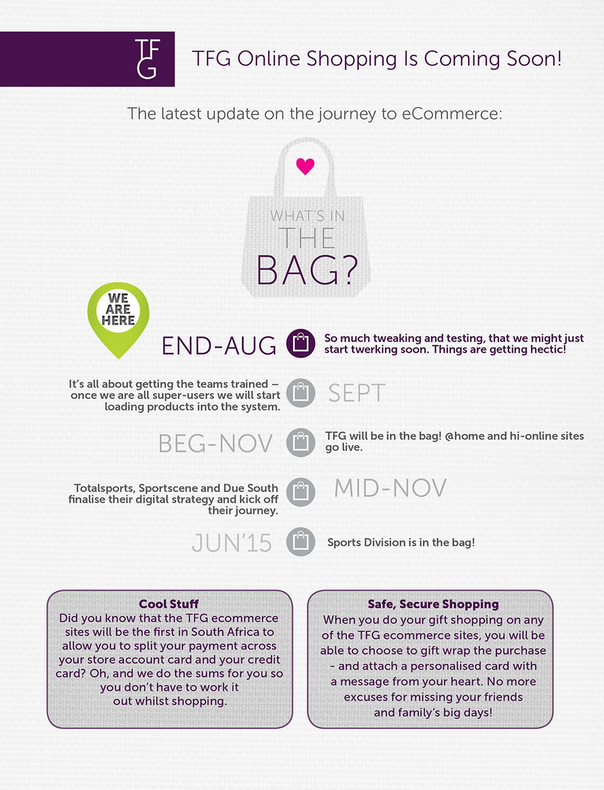

*Appendix B*

*E-Government Research and insights*

*The research was conducted to investigate the relationship between e-governance and e-business mainly within the wholesale and retail sector. The finding was that the South African government and its respective departments are utilizing the website to provide certain government services to the citizens.*

*Let us first start by providing the following definitions-*

*Electronic Government* (or *e-Government*) essentially refers to "The utilization of Information Technology (IT), Information and Communication Technologies (ICTs), and other web-based telecommunication technologies to improve and/or enhance on the efficiency and effectiveness of service delivery in the public sector." e-Government promotes and improves broad stakeholder’s contribution to national and community development, as well as deepen the governance process.

E-government describes the use of technologies to facilitate the operation of government and the dispersement of government information and services. E-government, short for electronic government, deals heavily with Internet and non-internet applications to aid in governments. E-government includes the use of electronics in government as large-scale as the use of telephones and fax machines, as well as surveillance systems, tracking systems such as RFID tags, and even the use of television and radios to provide government-related information and services to the citizens.

Examples of e-government and E-governance.

E-Government should enable anyone visiting a city website to communicate and interact with city employees via the Internet with graphical user interfaces (GUI), instant-messaging (IM), audio/video presentations, and in any way more sophisticated than a simple email letter to the address provided at the site”and “the use of technology to enhance the access to and delivery of government services to benefit citizens, business partners and employees”The focus should be on:

* The use of [information and communication technologies](http://en.wikipedia.org/wiki/Information_and_communication_technologies), and particularly the Internet, as a tool to achieve better government.
* The use of information and communication technologies in all facets of the operations of a government organization.
* The continuous optimization of service delivery, constituency participation and governance by transforming internal and external relationships through technology, the Internet and new media

Whilst e-government has traditionally been understood as being centered on the operations of government, e-governance is understood to extend the scope by including citizen engagement and participation in governance. As such, following in line with the OECD definition of e-government, e-governance can be defined as the use of ICTs as a tool to achieve better governance.

*The biggest challenge that e-governance has is similar to those of the wholesale and retail sector.Goverment together with the W&R sector need to provide the skills component/training needs to both users and human capital. The two sectors must collaborate to improve the telecoms infrastructure in order to enable.Goverment also needs to assist with access to affordable internet services.*

*Recommendations*

*Government must improve on the e-commerce space on their services i.e. Retail service bonds, South African social security agency (SASSA) payout etc.*

*Government to provide more skills through their sector education and trainings.*

*Government to increase funding on training through its sector education and training.*

*Government to engage telecoms service providers through its institutions like independent. communication authority of South Africa( ICASA) to provide affordable data usage which will benefit retail online space.*

***Appendix C***

***What is e marketing?***

Very simply put, [**e Marketing**](http://www.quirk.biz/resources/glossary/E#emarketing) or electronic marketing refers to the application of marketing principles and techniques **via electronic media** and more specifically the Internet. The terms **e Marketing**, **Internet marketing** and **online marketing**, are frequently interchanged, and can often be considered synonymous.

It includes both direct response marketing and indirect marketing elements and uses a range of technologies to help connect businesses to their customers.

**Why is it important?**

When implemented correctly, the **return on investment** [(ROI)](http://www.quirk.biz/resources/glossary/R#roi) from e Marketing can far exceed that of traditional marketing strategies.

Whether you're a "bricks and mortar" business or a concern operating purely online, the Internet is a force that cannot be ignored. It can be a means to reach literally millions of people every year. It's **at the forefront of a redefinition** of way businesses interact with their customers.

## The benefits of e Marketing over traditional marketing

### Reach

The nature of the internet means **businesses now have a truly global reach**. While traditional media costs limit this kind of reach to huge multinationals, e Marketing opens up new avenues for smaller businesses, on a much smaller budget, to access potential consumers from all over the world.

### Scope

[Internet marketing](http://www.quirk.biz/home) allows the marketer to reach consumers in a wide range of ways and enables them to offer a wide **range of products and services**. E Marketing includes, among other things, information management, public relations, customer service and sales. With the range of new technologies becoming available all the time, this scope can only grow.

### Interactivity

Whereas traditional marketing is largely about getting a brand's message out there, e Marketing facilitates conversations between companies and consumers. With a **two-way communication channel**, companies can feed off of the responses of their consumers, making them more dynamic and adaptive.

### Immediacy

Internet marketing is able to, in ways never before imagined, **provide an immediate impact**.

Imagine you're reading your favourite magazine. You see a double-page advert for some new product or service, maybe BMW's latest luxury sedan or Apple's latest iPod offering. With this kind of traditional media, it's not that easy for you, the consumer, to take the step from hearing about a product to **actual acquisition**.

With e Marketing, it’s easy to make that step as simple as possible, meaning that within a few short clicks you could have booked a test drive or ordered the iPod. And all of this can happen regardless of normal office hours. Effectively, Internet marketing makes business hours 24 hours per day, 7 days per week for every week of the year.

By closing the gap between providing information and **eliciting a consumer reaction**, the consumer's buying cycle is speeded up and advertising spend can go much further in creating immediate leads.

Reference: Quirk e marketing 101

*Appendix D*

*An Example of the survey conducted by team members across Woolworths, Foschini, Pick and Pay.*

|  |  |  |
| --- | --- | --- |
| |  | | --- | | Company Name | |  |
| Company Representative Name |  |
| Company Representative Job Title |  |
| Core Business |  |
| Size of Company |  |
| Number of employees  (Part time and Full Time) |  |
| Meeting Lead by: |  |

1. What is the purpose of your business?

**Trade online to a wider captive audience and have the product range accessible in areas where pharmacies are not stocking the range**

____________________________________________________________

1. What is your percentage sales split of online versus traditional sales?

**10% online vs. 90% in store retail sales** _____________________________________________________________

1. What type of skills does your business currently require for e-business?

**IT - ecommerce skills ; digital marketing skills with a great understanding of online marketing , working knowledge of web fundamentals, understanding of SEO as well as the ability to learn new skills** ______________________________________________________________

1. What role do employee skills play in your company’s ability to respond e- business requirements

**Skills are very important to grow the business and to be on the top of your game and with the right skills the business is able to develop different marketing channels via affiliates etc.** ______________________________________________________________

1. Is there a skills gap in your organization with respect to e-business?

**Yes, I believe there is. E-commerce business can increase considerably if person running the site is well equipped with digital marketing fundamentals and in-house maintenance of site; retail day to day trading and technical skills** ______________________________________________________________

1. If yes what are some of the reasons for the skills gap?

**Staff is not equipped with the understanding of ecommerce, not many opportunities for growth. Students to consider ecommerce and multi channel retailing as a career. Employees do not understand the integration of retailing and ecommerce. Poor knowledge of web fundamentals.** ______________________________________________________________

1. What do you think can be done to throw skills sets in e- business environment?

**Starting point schools should offer entrepreneurship with ecommerce as a major module as well as creating more courses for students to consider.**

**Accessibility of the web will assist students / employees to understand the channel. A thorough understanding of the businesses commerce business model**

______________________________________________________________

1. What is your company doing to bridge the gap in areas of skills shortage

**We are currently working on up-skilling our marketing department to enhance their digital skills, ups-killing our technical department so more of the site maintenance will be done in-house.** ______________________________________________________________

1. What are some of the risks that you foresee in up skilling the workforce?

**One of the major risks will be that employees will look for other lucrative jobs with better remuneration packages** _____________________________________________________________

1. Do you find that there are too few or no qualified candidates available for available positions within your company?

**Presently very few candidates are available with good insight and knowhow of ecommerce trading** ______________________________________________________________

1. Do you have sufficient funds available to pay for the skills your company requires?

**No, we don’t have sufficient funds; hence we would look at a current employee and up skill their skills**

______________________________________________________________

1. Are there sufficient and effective training programs in place, within your company to up skill the current workforce?

**Not at the moment, but we are looking into a training programme for staff to attend to up skill their current skills as well as a mentorship programme**

______________________________________________________________

1. Is your training budget adequate to address all or key training needs?

**Not at this time, but as the business grows, we plan to address continuous training in stages so that employees are always abreast with current trends in ecommerce trade._** ______________________________________________________________

1. What percentage of your workforce in the e-business platform is from the ‘older generation’?

**Non**

___________________________________________________________

1. What is their ability to learn and develop as the business changes?

**N/A**

_________________________________________________________

1. Is retention a problem in your company?

**Not at the moment, but we have a retention plan in place, once the staff are up-skilled with incentive bonuses in place**_________________________________________________________

1. If so why?

**N/A**

______________________________________________________________

1. What do you think the solutions are with respect to retention?

**Pay staff a market related salary.**

**Provide a good, professional working environment with incentive packages and ensuring the employees are provided with continuous education** ______________________________________________________________

**Some of the key insights derived from the above survey a total of 50 people surveyed:**

* Businesses are engaging in online applications example – Omni Channel and are taking a more strategic view on E- Business.
* Traditional brick and mortar ways of the customer interacting with the brand is experiencing exponential change in the world, Africa and South Africa.
* Business needs to supplement other ways of interacting with the consumer.
* We need to adopt an anywhere/ anytime on line retail trend direction.
* Some of the challenges retailers’ faces today are technical in nature, for example bandwidth and internet connectivity.
* Government involvement and offering free Wi-Fi zoned areas enables the consumer to shop online cheaper.
* Culturally we are very security aware and with a lack of online business there is a lack of trust.
* South African Retailers are very conservative in their approach to e-business. A Visible and tangible ROI is what retailers want to see before making this investment.
* Currently in South Africa Woolworths and Mr Price are ahead of other local retailers with online applications which give these retailers a competitive advantage.
* With regards to skills development retailers need to employ people with more digitally savvy skills sets across all areas of the business including the CEO.
* Interacting with customers on social media is a necessity. It allows one to communicate with customers, sharing messages, promotions, opinions, etc. Customers also share their thoughts about the companies and their experience with it. However, social media can also be a quagmire, since this is largely unregulated, mostly uncensored, and could easily spiral out of control.
* It is therefore critical that a company formulates and adopts a clear strategy on how, when, on what issue and with what wording do we enter into the fray, on social media.

*Appendix E*

*International immersion subject matter related to e-business, marketing and consumer trends. There is a view that e-business and online platforms will form a percentage of retail revenue. Brick and Mortar will remain the conventional way to shop however business will need to adopt a strategy to satisfy the millennial needs.*

* Deloitte Digital
* Focus to make it easy to transact example – Chrysler innovates
* Seamless conversion of all devices.
* They don’t change people processes they digitalise there in house process and integrate systems.
* Create virtual reality experiences, a focus on the customer experience.
* How does Deloitte embed education through collaboration –there is a focus on transferring the skills to industry. Or managing the process for the organisation.
* Culture of continues improvement – create a feedback loop to improve.
* Speed of technology – constant change.
* NRF – the National Retail Federation
* There is a focus on cross company collaboration and sharing of best practices in the industry.
* Skills portal - paper been posted regarding risk and skills development.
* Data security related to e-business
* Criminals moving just as fast as technology.
* USA Embassy – actively use the consulate and embassy in different countries to establish best practice for South Africa.
* Seasonal irrelevance – looking at buying processes differently.
* Millward Brown – Doreen Wang/ Marc De Swaan / Nicky Cunliffe
* The emphasis based on reaching consumers through online marketing / Omni Channel
* Shop beam – Georgia Bernadette.
* Focused on end use and ease of shop across brands/ boarders/ lifestyles.
* A truly convenient way to shop retailers all over the globe.
* MasterCard
* Integration of better payment options in SA and in Africa.
* Street visits to various stores.
* Nike store in New York has integrated systems that talk to the customer shopping experience as well as stock room technologies for quick access to product.